**Godawan 100 is Crowned ‘Single Malt Whisky of the Year’**  
  
*The Collector’s-Edition artisanal single malt scored 96 points at the* ***2024 London Spirits Competition****, becoming the top scorer in the single malt whisky category in the world.*  
  
*This win solidifies Godawan’s position as the most awarded Indian single malt in 2023-24 – with 42* *national and international accolades.*

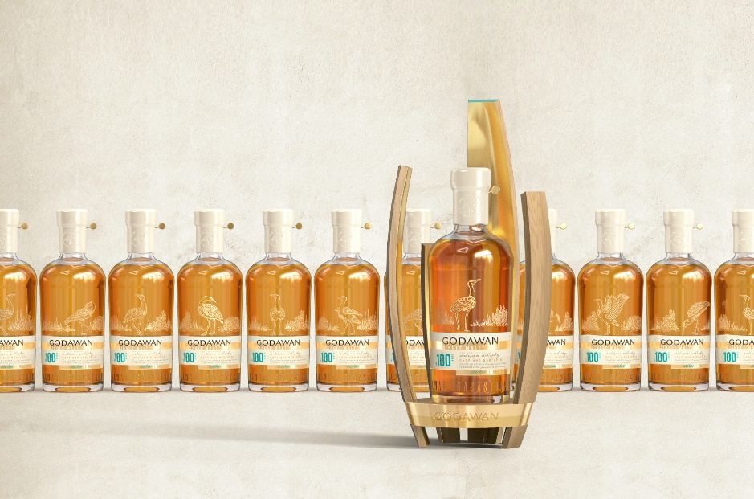

**Bangalore, April 17, 2024:** Godawan 100, a Collector’s-Edition artisanal single malt, crafted by Diageo India, has been crowned the ‘Single Malt Whisky of the Year’ at the prestigious **2024 London Spirits Competition.** This leading international spirits’ competition evaluates spirits based on quality, value, and packaging, with assessments made by discerning trade buyers. With 96 points, Godawan 100 **topped** the score charts in the single malt whisky category from across the world.

With only 100 bottles available, Godawan 100 is a rare Collector’s Edition single malt that boasts pronounced tropical notes, a lighter palate and a short finish. Its sweet palate reveals notes of caramel, charcoal, cinnamon, and anise, leading to a long, dry finish. **Filip Stribrny, Judge, London Spirits Competition**, explains why Godawan 100 stands apart. *“Godawan 100 is a very complex whisky, with rich flavours of dried fruits, sultanas, and dark chocolate. It also has a very balanced flavour profile with a dark, dry finish of oak.”*

[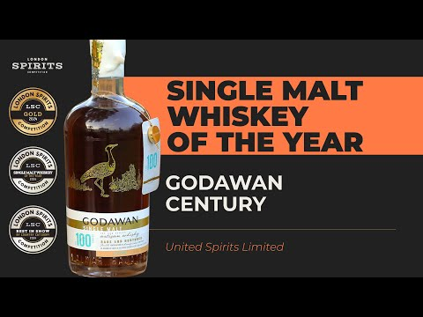](https://www.youtube.com/watch?v=xA-cUbOy-hw)

Link: <https://www.youtube.com/watch?v=xA-cUbOy-hw>

As India’s first artisanal single malt whisky born out of Rajasthan, Godawan is pushing boundaries in whisky craftsmanship by challenging perceptions and defying traditional whisky production norms. This can be witnessed in the other expressions from the brand portfolio, **Godawan** **01 Rich and Rounded** and **Godawan 02 Fruit and Spice**, **being awarded gold medals at the London Spirits Competition 2024**.

“Judges loved the quality of producers from India in the 2024 edition of London Spirits Competition and among the brands, Godawan was the best-preferred brand where all the products from the brand got gold medals,” said Sid Patel, CEO of Beverage Trade Network, organiser of London Spirits Competition.

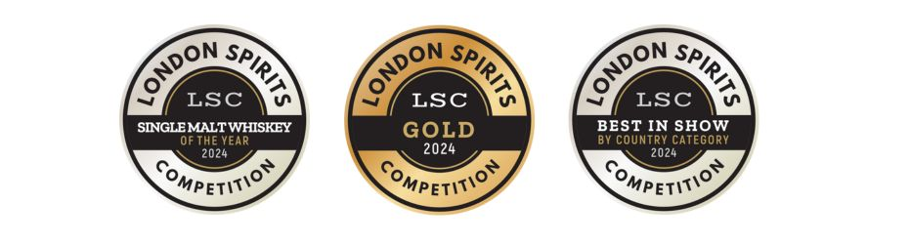

These prestigious wins add to the Godawan’s record tally of **42 national and international accolades** for its liquid innovation, packaging design, and marketing campaigns – establishing it as the most awarded Indian single malt in the recent times. In 2023, the whisky made India proud at the globally renowned **Monde Selection Quality Awards** in Brussels – securing a **Grand Gold Medal** for its **02 Fruit and Spice Expression** and a **Gold Medal** for its **01 Rich and Rounded expression**.   
  
The whisky is slow-trickle distilled from locally sourced six-row barley, thereby extracting optimal sensory performance. Distilled in Alwar, Rajasthan, the liquid is uniquely matured at temperatures exceeding 100°F, resulting in a whisky with a rich and complex character. The arid climatic conditions observed in Godawan contribute to a heightened “Angel’s share” phenomenon, imparting an extraordinary flavour profile that enthralls the senses.

Godawan is bringing to life a range of Indian single malts that will cater to every palate - Light and Floral, Fruity and Spicy, Rich and Rounded, Full bodied and Smoky. It achieves this by crafting a mother liquid that is flexible enough to manifest itself across each flavour profile. Godawan’s 01 Rich and Rounded expression offers notes of sultanas and dried fruits on the nose, and raisin, sultana, fig, and apricot on the palate. The finish ends with mature wood, caramel, and a butteriness like baklava. Godawan’s 02 Fruit and Spice expression has fruity aromas on the nose and a palate that boasts rich fruit and floral notes, along with vanilla, sweet ginger, and coconut. It leaves a lingering finish with a dash of spice and roasted coffee beans.

With a core focus on conservation, sustainability, and conscious consumption, Godawan is curating mindful luxury that pays tributes to its roots, its heritage, and most importantly, its environment. The whisky derives its name from the Great Indian Bustard, a majestic bird once widespread across India but now marked Critically Endangered in the IUCN Red List. With approximately 150 left in India, these regal creatures have taken their last refuge in Rajasthan. With every bottle of Godawan sold, the company contributes to conserving the habitat of these birds, allowing them to flourish.  
  
**Website** - <https://www.godawansinglemalt.com/>   
**Instagram** - <https://www.instagram.com/godawansinglemalt/?img_index=1>

**###**

**About The Good Craft Co.**

Godawan Artisanal Single Malt Whisky is a product of The Good Craft Co., Diageo India’s craft and innovation hub. It was set up in 2022 to accelerate transformational innovation and strengthen the brand’s craft and premium drinks portfolio. The Good Craft Co. also acts as an incubator to accelerate the alco-bev start-up ecosystem.

**About Diageo India**

Diageo India is among the country’s leading beverage alcohol company and a subsidiary of global leader Diageo Plc. The company manufactures, sells and distributes an outstanding portfolio of premium brands such as Johnnie Walker, Black Dog, Black & White, VAT 69, Antiquity, Signature, The Singleton, Royal Challenge, McDowell’s No1, Smirnoff, Ketel One, Tanqueray, Captain Morgan and Godawan, an artisanal single malt whisky from India. Headquartered in Bengaluru, our wide footprint is supported by a committed team of around 3000 employees, 36 manufacturing facilities across states and union territories in India, a strong distribution network and a state-of-the-art Technical Centre. Incorporated in India as United Spirits Limited (USL), the company is listed on both the National Stock Exchange (NSE) and Bombay Stock Exchange (BSE) in India.

For more information about Diageo India, our people, our brands, and our performance, visit us at www.diageoindia.com. Visit Diageo’s global responsible drinking resource, http://www.DRINKiQ.com, for information, initiatives, and ways to share best practices.  
  
Celebrating life, every day, everywhere.   
  
**Godawan Artisanal Single Malt Media Contact**  
Riddhi Mehra  
[godawan@theoutlierpr.com](mailto:godawan@theoutlierpr.com)+91 7829502363